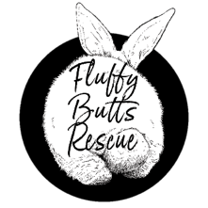
Rabbit Adoption Form
Name:
Contact information:

Address:

Name of rabbit(s) interested in or information to help us find a potential match (e.g. what kind of temperament, age, size etc.)

Do you have experience of looking after rabbits?

Vet contact details:
Current rabbits’ diet (e.g., pellet brand) or planned diet:
Do you already have a pet rabbit/s? Are they neutered and up to date with vaccinations? We will require evidence of this.
.

What is your current set up? We will require some photos, to ensure it is suitable.
The RAWF minimum guidance is a hutch 6ftx2x2 with an 8 ft run (60 square foot at all times), in a predator proof enclosure.

Do you have any other pets?

Do you have children?

We require £15 deposit each rabbit to reserve them (this gets taken off the adoption fee).
We are happy to advise on anything if you have any questions.

