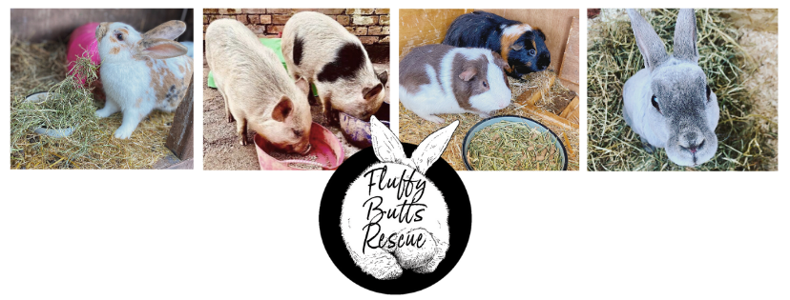
Fostering Interest Form

Name: Click or tap here to enter text.
Contact number: Click or tap here to enter text.

Address: Click or tap here to enter text.

Are you over 18 years old: Yes ☐ No☐

The animals I am able and would like to foster include:
☐Rabbit
☐Guinea pig
☐Mice
☐Rat
☐Other small animal

Experience with animals or previous fostering:
Click or tap here to enter text.

Why would you like to foster?
Click or tap here to enter text.

Do you already have a set up or an area that would be suitable for a set up:
Click or tap here to enter text.

Describe your current home environment (please include any other animals you have, hours a foster animal will be left for, regular visitors including children)
Click or tap here to enter text.

Do you have access to private transport? (e.g. own car): Yes ☐ No☐

Any other details that may be important in regards to your application:
Click or tap here to enter text.

We will get back to you as soon as possible once your application has been submitted, please not this may take several days.
If you have any question in regards to this form or fostering please do get in touch.
Thank you, from the Fluffy Butts Team

